1. 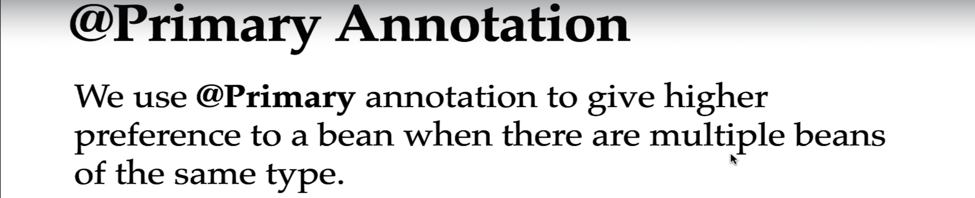
2. 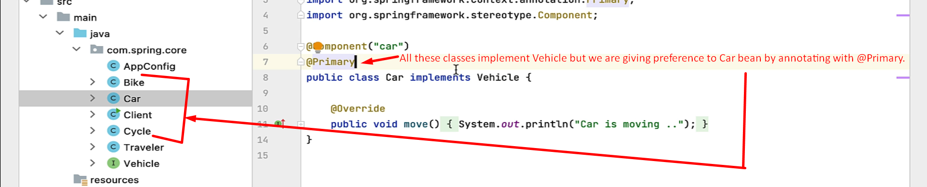
3. 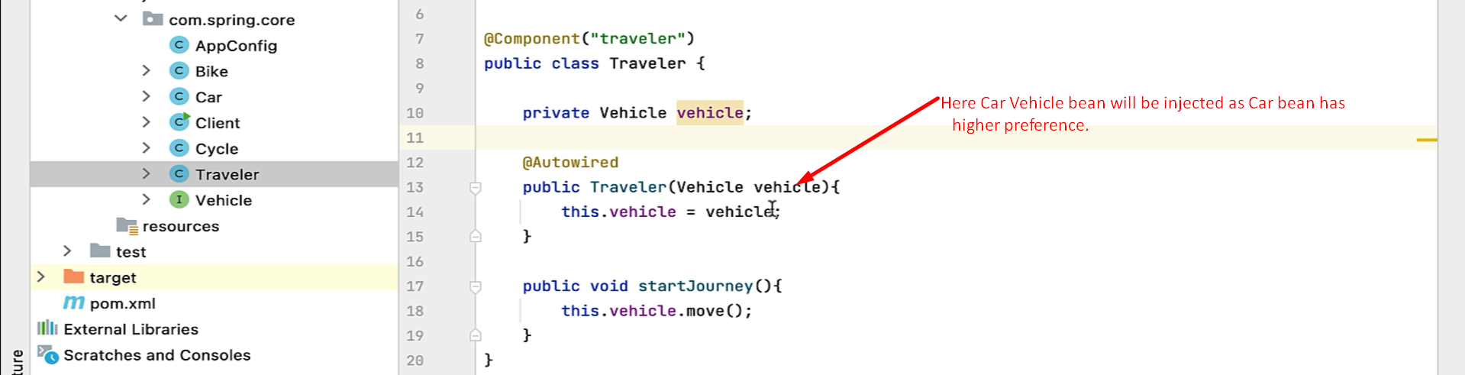
4. 
5. Another use case for **@Primary annotation** is when based on environment, we want to inject a different DataSource like MySQL, PostgreSQL etc.   
   Then we can annotate a particular DataSource with @Primary based on the environment.